Software Engineering Assignment

MODULE: 1

SE – Overview of IT Industry

1. **What is software? What is software engineering?**

Ans.

* Software :

Software is a program or set of programs containing instructions that provide desired functionality. Engineering is the process of designing and building something that serves a particular purpose and finds a cost-effective solution of problems.

* Software Engineering :

Software Engineering is the process of designing, developing, testing, and maintaining software. It is a systematic and disciplined approach to software development that aims to create high-quality, reliable, and maintainable software.

1. **Explain types of software.**

Ans.

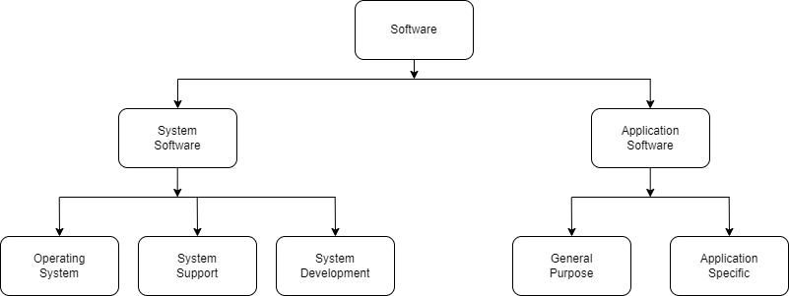

* System Software :
* System Software is the most important type of software required to administer the resources of the computer system.
* System software runs and functions internally with application software and hardware. Moreover, it works as a linking interface between a hardware device and the end-user.
* System software runs in the background and manages all functioning of the computer itself. It is called Low-Level Software as it runs at the most basic level of computer and is usually written in a low-level language. As soon as we install the operating system on our device, it gets automatically installed on the same device.
* Example : Operating System , BIOS , System Support , System development
* Application Software :
* An Application Softwareis basically is a program or set of programs that perform a specific task. In addition to this, end-users use this software. Hence, the name end-user programs.We can also name this software asan app. There are different types of application [software](https://www.toppr.com/guides/computer-aptitude-and-knowledge/basics-of-computers/hardware-and-software/) both for simple as well as complex tasks.
* They enable the computer to perform specific tasks like processing words, handling calculations, accounting, result preparation etc. Some basic examples are MS-Word, Photoshop, Google Chrome, etc.
* Example : General purpose software , Customize Application Software

1. **What is SDLC? Explain each phase of SDLC.**
   * Software development life cycle (SDLC) is the term used in the software industry to describe the process for creating a new software product.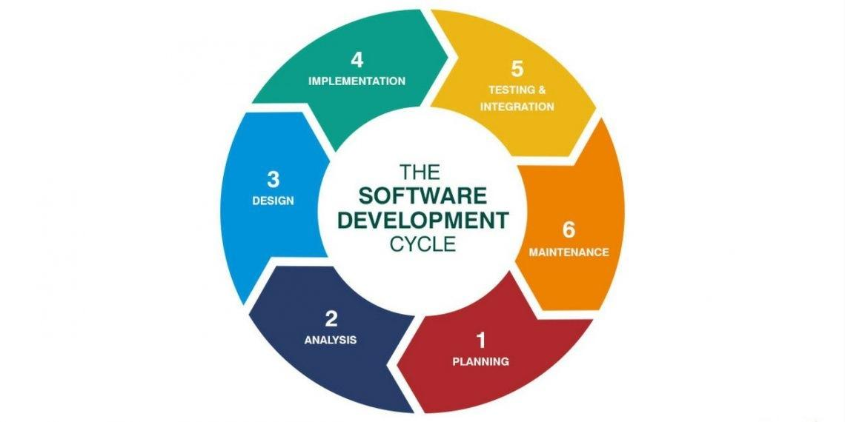

### Stage 1: Plan and brainstorm.

The first step in the software development life cycle is planning. It's when you gather the team to brainstorm, set goals, and identify risks. At this stage, the team will work together to devise a set of business goals, requirements, specifications, and any high-level risks that might hinder the project's success.

### Stage 2: Analyze requirements.

Once you've come up with some ideas, it's time to organize them into a cohesive plan and design. This requires a lot of research and planning to ensure that your final product meets your expectations (and those of your customers). The big step is creating a detailed project plan document and work breakdown structure that outlines the requirements.

### Stage 3: Design the mockups.

Once you've got your design plans in front of you, it's time for wireframing and mockups. This step builds upon the planning stage, building out the tasks you need to do in the work breakdown schedule. There are plenty of tools available, such as Adobe XD or In Vision, that make this process much easier than ever before.

### Stage 4: Implementation (Develop the code).

The development phase is where coding begins to take place. It is one of the most time-consuming phases in the SDLC. This phase often requires extensive programming skills and knowledge of databases. The team will build functionality for the product or service, which includes creating a [user interface](https://www.coursera.org/articles/ui-design) and building the database so users can store information in your system.

### Stage 5: Test the product.

Before releasing the mockups into final production, you'll need to test it to ensure it is free of bugs and errors. Any issues need to be fixed before moving forward with deployment. You'll also need to manage how the system will integrate into existing systems, software, and processes.

### Stage 6: Implement, launch the product and Maintenance

Once you've completed all testing phases, it's time to deploy your new application for customers to use. After deployment, the launch may involve marketing your new product or service so people know about its existence. If the software is in-house, it may mean implementing the change management process to ensure user training and acceptance.

The final stage of the software development life cycle is maintenance and operations. This is one of the most critical stages because it's when your hard work gets put to the test.

Maintenance involves updating an existing software product to fix bugs and ensure reliability. It can also include adding new features or functionality to a current product. Operations refer to the day-to-day running of a software product or service, such as performing backups and other administrative tasks.

1. **What is DFD? Create a DFD diagram on Flipkart.**

DFD is the abbreviation for Data Flow Diagram. The flow of data of a system or a process is represented by DFD. It also gives insight into the inputs and outputs of each entity and the process itself.

It provides an overview of

* What data is system processes.
* What transformation are performed.
* What data are stored.
* What results are produced , etc.
* DFD diagram of Flipkart :

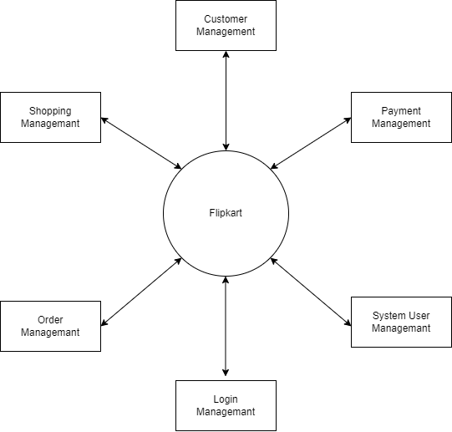

0 Level DFD of Flipkart

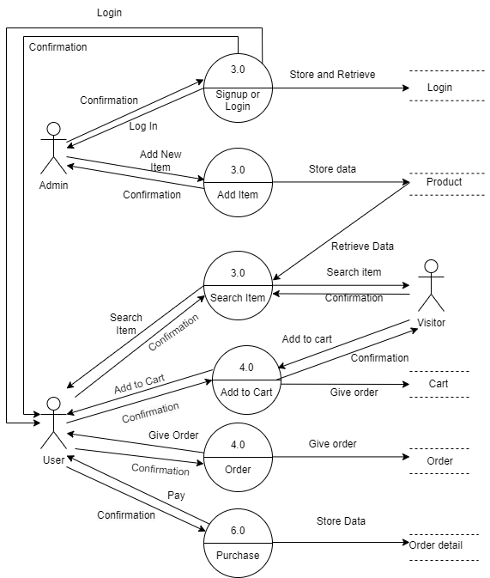

1 Level DFD of Flipkart

1. **What is Flow chart? Create a flowchart to make addition of two numbers.**

A flowchart is a type of diagram that visually explains a process or workflow. By using standardized symbols and definitions, you can create a handy visual representation of any process's various steps and decision points.

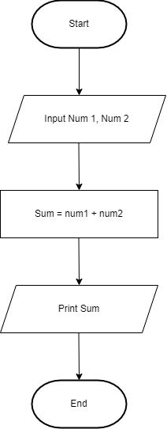

Flowchart

1. **What is Use case Diagram? Create a use-case on bill payment on paytm.**

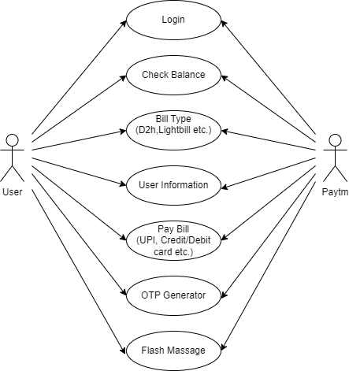A use case diagram is the primary form of system/software requirements for a new software program underdeveloped. Use cases specify the expected behavior (what), and not the exact method of making it happen (how). Use cases once specified can be denoted both textual and visual representation (i.e. use case diagram).

Use case Diagram